Romance Anime:

Violet Evergarden

Violet Evergarden is a romance anime that follows the story of the titular character, who was used as a “tool” for her combat prowess during a war set in an fantasy-industrial age setting. It was during this war that Violet would lose her arms in the last decisive battle of the war. The character of Violet is depicted as a stoic and emotionless character as she wakes up from a hospital bed with mechanical arms months later, with her only concern being where her commanding officer Gilbert is. However, she is not informed that Gilbert had died in that battle. Gilbert’s last words to Violet were “I love you”, which leave her confused as she was raised as a “tool” and not a human being. Confused by these words, she joins a company lead by Gilbert’s friend who employs her as a Auto Memory Doll, a person who write down the emotions of customers and send these letters to their recipients. Through her experiences as a Auto Memory Doll, she learns what the words “I love you” means as well as how to act like a normal human instead of a “tool” for war.

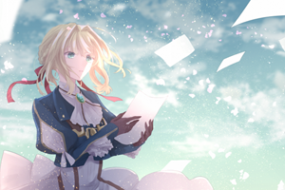

What makes Violet Evergarden different as a romance anime is the different setting and the character of Violet Evergarden herself. The industrial age setting is extremely different from a romance anime that takes place at a high school. This allowed the creators to create situations that would be able to emphasize the emotions that Violet is to learn in order to understand what it means to be human. In addition to this, unlike a regular high school student, the anime follows the story of a soldier-turned-civilian who is looking to understand the final words of her commanding officer, which is not seen anywhere else. These reasons make it a must watch for any Romance anime lover.

Not Your Cup of Tea? Have a Look at the Other Romance Anime!

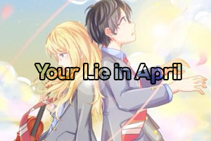

Or… Discover Another Genre:

Action genre button link Adventure genre button link

Comedy genre button link Drama genre button link